Name of CME Provider

Certificate of Attendance

This certifies that

Learner’s Name

attended the educational program entitled

Title of Event
Date of Event

This Performance Improvement CME activity has been reviewed by the AAPA Review Panel and is compliant with AAPA CME Criteria. This activity is designated for a maximum of X.X AAPA Category 1 PI-CME credits. Approval is valid from Start Date to End Date. PAs should only claim credit commensurate with the extent of their participation. AAPA reference number: CME-#######.
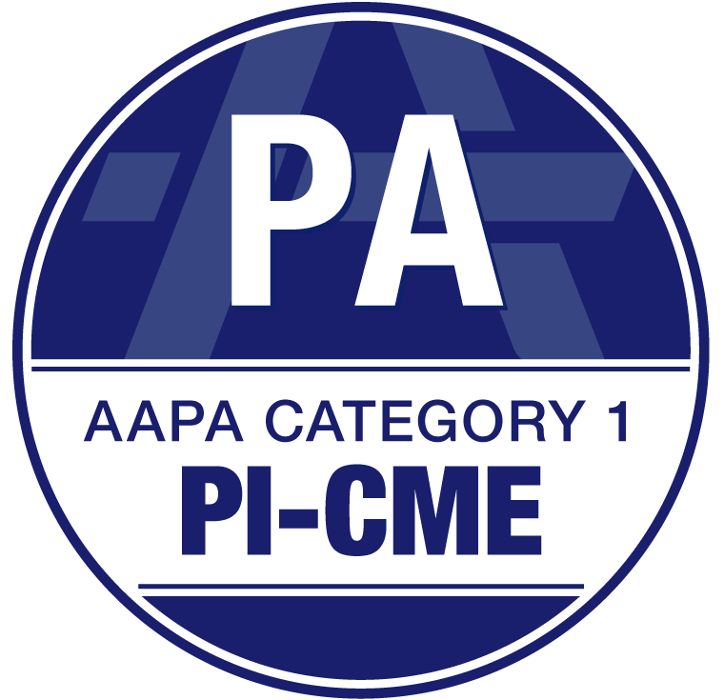
For NCCPA certification maintenance ONLY, the first 20 PI-CME credits logged during every two-year cycle will be doubled by NCCPA. PAs should log up to a maximum of X.X AAPA Category 1 PI-CME credits, as the additional weighting will be automatically applied by NCCPA.

